Top of Form

**Modeling and Simulation for Fast Food Supply Chain Management**

Lu Lin, Columbus State University, [lin_lu@columbusstate.edu](mailto:lin_lu@columbusstate.edu)

INSTRUCTOR: Dr. Anastasia Angelopoulou

**Keywords**

Modeling and simulation; Supply Chain Management; Conceptual Model and Computer Program; Logistics; Model Verification and Validation.

**Abstract**

In this paper, ARENA software is used to build models and simulate a supply chain management research case study. Author analyzes reports generated from the simulation and present several optimization alternatives with comparison.

1. **Introduction**

Nowadays, fast food industries have evolved into some of the most diverse and important businesses in the world. This evolution would not be possible without effective supply chain management (SCM). Supply chains involve all aspects of producing and supplying products to customers, including basic material supplies, products manufacture, customer ordering and order management, inventory control and transportation.

Modeling and simulation (MS) has been increasingly applied to a wide range of disciplines. MS allows users to represent a system and examine its operations using different possible scenarios and conditions, and to explore various possibilities then determine optimal policies. As a result, it is a logical move to apply MS to SCM in fast food industries. The strength of MS lies in the understanding of SCM systems and characteristics, the SCM optimization, the cost control, and the risk management. To summarize, MS is a powerful tool to support SCM decision making.

The SCM process in fast food supply chain can be divided into a series of cycles each perform among various successive stages. As Figure 1 shows, it is a typical SCM process:

* 1. Order is triggered when the inventory reaches a certain low point as it is consumed.
  2. Verify the product availability.
  3. Select the appropriate product based on availability, cost, quantity, delivery date, etc.
  4. Receive, store, and distribute.
  5. Budge and inventory management.

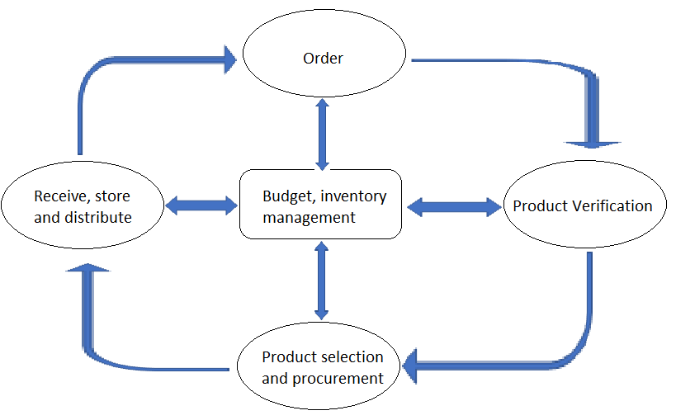

**Figure 1. Fast Food SCM Process**

Some aspects of behavior of SCM are illustrated as above. Three specific important aspects are the fluctuating inventory level, process time, and customer demand. Many other aspects may be investigated, but it is enough for the following case study. For illustration to discuss only a few simplifications here, I establish a sub model as part of SCM model for case study. There could be many independent sub models for a SCM simulation model; the integration of these sub models could save lots of work and efforts.

1. **Case Study Background**

The case of interest is the supply chain (SC) of a local fast food chain store. Five food suppliers serve as create units of this model to produce “food” as the main Entity in this simulation model. Each food supplier produces food based on a certain distribution model. For example, the first supplier produces food based on triangular distribution.

Food is sent to two storage centers (east and west) waiting for distribution. Because of geographical limitation, food supplier 1-3 can only ship to east storage center and food supplier 4-5 can only ship to west. Storage centers are process units that can seize, delay and release a certain number of “storage space” as the first Resource in this simulation model.

Finally, food is distributed to five local restaurants. Also because of geographical limitation, east storage center can distribute food to restaurant 1-2 whereas west storage center can distribute to restaurant 3-5. Restaurants are another type of process unit that can seize, delay and release a second type of Resource “consumption”. After consumption food is disposed.

1. **Simulation and Reports**

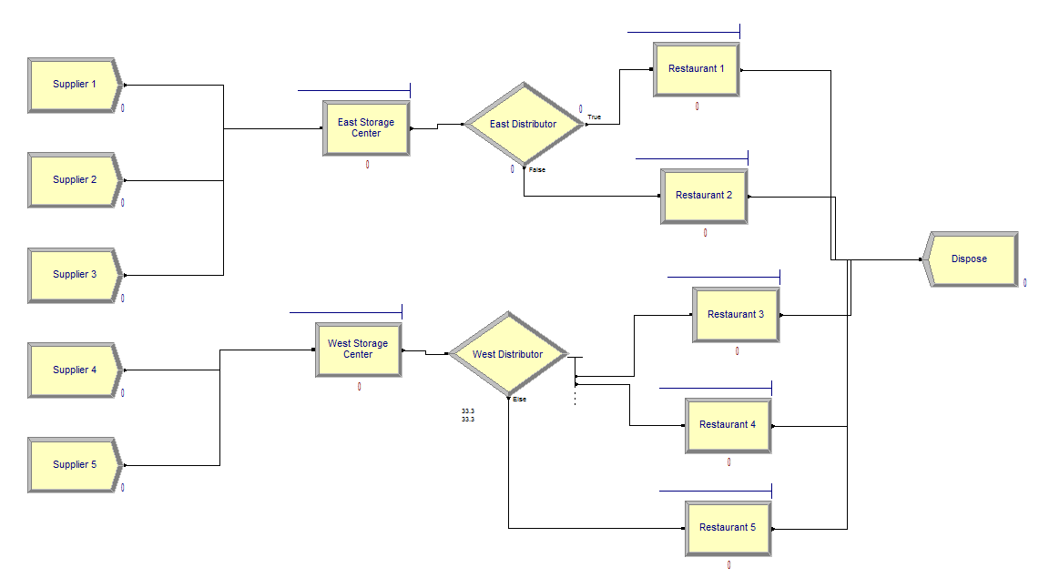

**Figure 2. Flow Chart**

1. Simulation configuration
   1. One type of Entity named “Food” is produced by five suppliers, following triangular distribution TRIA(5, 6, 7) in minutes.
   2. East and West Storage Center both seize, delay and release one type of Resource named “FoodStorage”. The delay time is set to 20 minutes, simulating that it takes 20 minutes to store a unit of food and prepare for distribution. The maximum capacity is set to infinity to simplify our model, whereas in practice storage capacity should be limited.
   3. East and West Distributor distributes entities randomly. East Distributor is two-way by 50% chance and West Distributor is N-way by chance, each of which is at 33.3%.
   4. Restaurant 1 – 5 all seize, delay and release their own resources, named “Consumption(1-5)”. The delay time is all set to follow triangular distribution TRIA(0, 2, 15) in minutes. To simplify our model, the maximum capacities are all set to 1, meaning that each restaurant can only process (sell) one unit of food at once.
   5. We ran 10 replications to minimize randomness, each of which runs for 2 hours.
2. Report highlights
   1. Total number out (number of foods disposed): 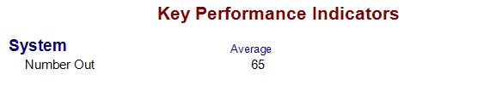

**Figure 3. KPI**

* 1. Total number of resources seized: 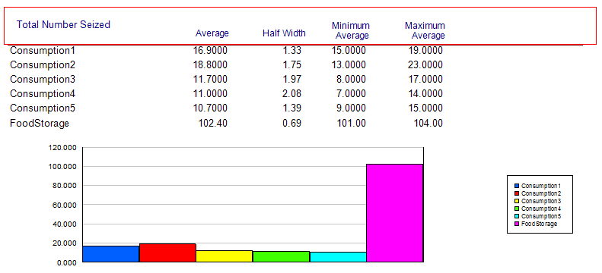

**Figure 4. Resource – Total Number Seized**

* 1. Queue waiting time: 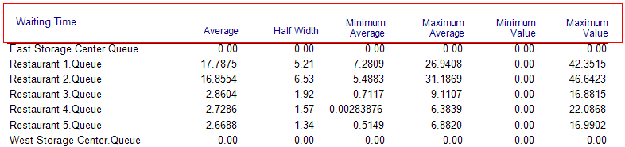

**Figure 5. Queue – Waiting Time**

* 1. Queue number waiting: 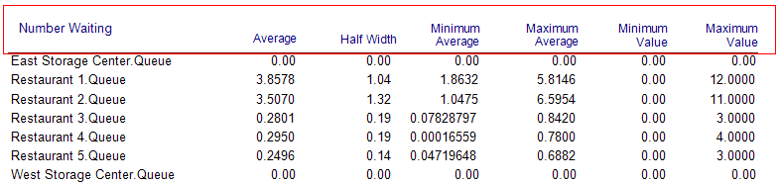

**Figure 6. Queue – Number Waiting**

1. **Optimization and Comparison**
   1. Identify Bottleneck

Based Figure 4-6, the main bottle neck happens on the east side where the processing power of two restaurants cannot keep up with the speed of the entity produced and distributed to them, thus causing long wait time in queue.

* 1. Balance Distribution

One possible solution to the above bottle neck is to make East Distributor distribute to restaurant 3 and leave only restaurant 4 and 5 to West Distributor. The re-balanced flowchart is shown as follows: 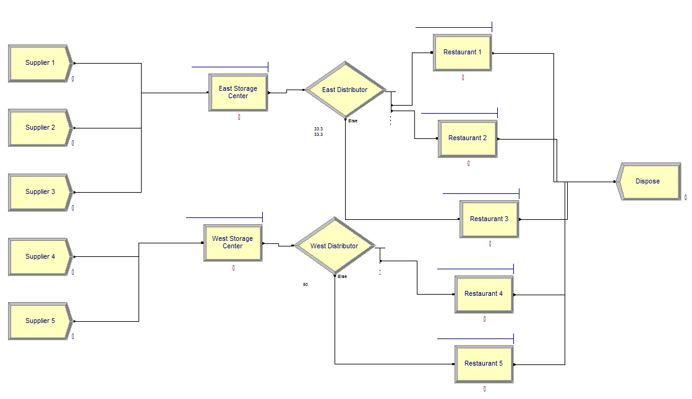

**Figure 7. Flowchart (Balanced)**

Simulation report shows more balanced usage of restaurant resources and queue wait time: 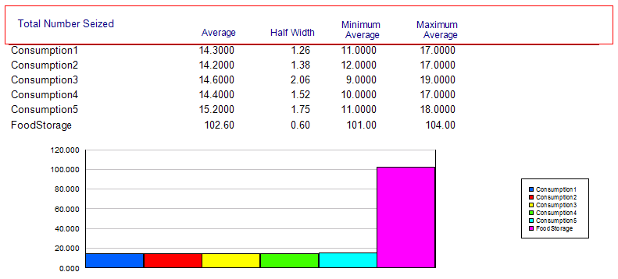

**Figure 8. Resource – Total Number Seized (Balanced)**

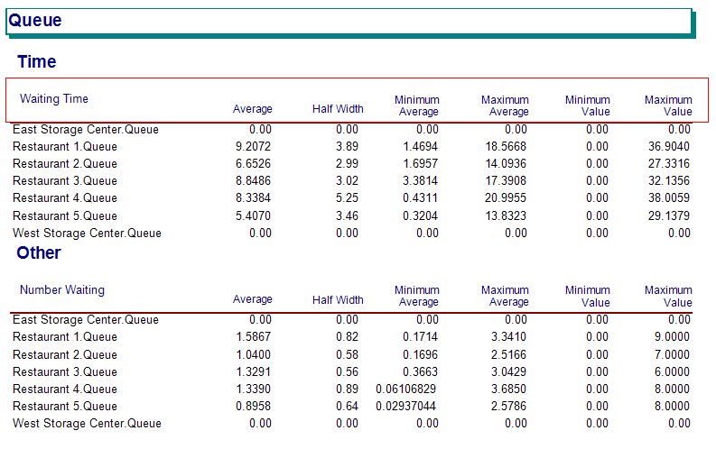

**Figure 9. Queue Time (Balanced)**

However, the overall processing power of the system does not increase because of this change. KPI remains approximately the same. 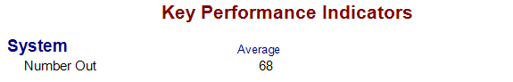

**Figure 10. KPI (Balanced)**

* 1. Additional Processing Units

To increase the overall processing power of the system and balance the resource usage, we can add extra processing unit to the system, by opening one more restaurant on the east side. The update flowchart is shown as follows:

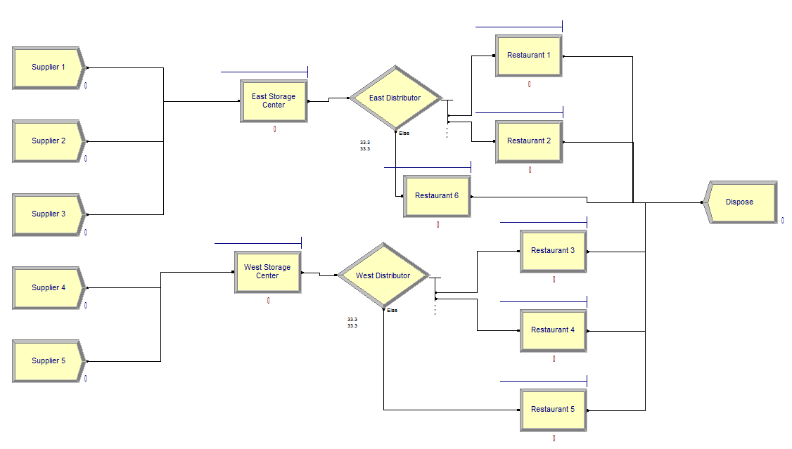

**Figure 11. Flowchart (Extra Restaurant)**

Firstly, the overall processing power increases, indicated by a larger KPI: 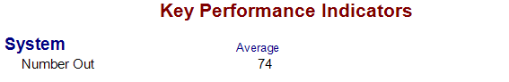

**Figure 12. KPI (Extra Restaurant)**

We also have a balanced usage of resources and queue wait time: 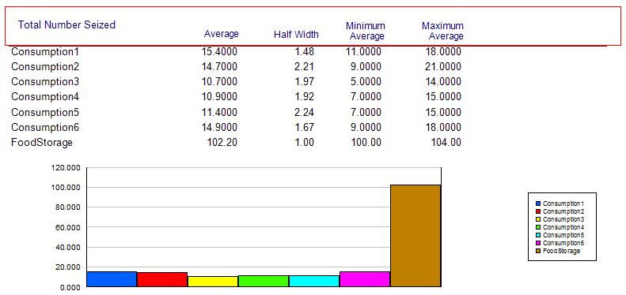

**Figure 13. Resource – Total Number Seized (Extra Restaurant)**

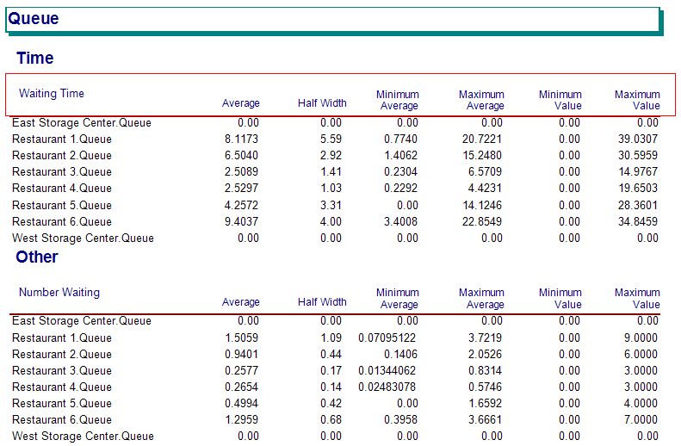

**Figure 14. Queue Time (Extra Restaurant)**

* 1. Cost Comparison

As shown above, opening extra restaurant can increase the overall processing power of the system and balance the supply chain. However, in practice the cost of an extra restaurant is significant, including rent, utility, management cost and human resources cost. Therefore, to eliminate the bottleneck of the supply chain without introducing too much overhead, fast food companies put a lot of emphasis on distributing their food supplies so that busier areas get more distribution and quieter areas get less.

1. **Conclusion and Main Findings**
   1. Conclusion

Through modelling simulation in ARENA, the author identifies the main bottle neck and propose possible solutions; the simulation indicates more balanced usage of resources and queue waiting time as well, hence the author propose to add extra processing unit to the system to increase the overall processing power of the system and balance the resource usage. Then, the cost of adding extra processing unit is compared, the cost-benefit balance should be taken into account when making decisions during processes of SC management.

* 1. Challenges for MS in Fast Food SCM

As far as the simulation model presented above, the most challenge faced by simulation and modeling community in fast food SCM are as follows:

* + 1. Collecting enough related input data. Data collection and validation is time consuming and subject to overwhelming and unnecessary details. The manually entered data may be inaccurate.
    2. Integration of sub models. Sub models perform at different levels of SCM, combining these sub models for saving efforts may bring issues during the process of exchanging information between sub models.
  1. Future Work

One of the directions that can be followed is to develop a library for fast food SC management policies. As revealed in case study the integration of sub models can be done within the process of SC for more experimenting scenarios.

Another research direction is to tackle the issue of cyber supply chains (such as Amazon.com), to study the usage of modeling and simulation for the analysis and optimization.

**References**

1. W. David Kelton, Randall P. Sadowski, Nancy B. Swets*. Simulation With Arena*. Fifth Edition, Mc Graw Hill.

2. Eman Abukousa, Jameela Al-Jaroodi, Sanja Lazarova-Molnar, Nader Mohamed. *Simulation and Modeling Efforts to Support Decision Making in Healthcare Supply Chain Management*. The Scientific World Journal, Volume 2014, Article ID 354246.

3. Saleh Eddine Ben Jbara. *Supply Chains Risk Management: A simulation and model-based approach, Computational Engineering*. Finance, and Science [cs.CE].

4. James Bekker, Sylvain Guittet-Remaud. *Simulation in Supply Chain: An Arena Basis*. The South African Journal of Industrial Engineering, Vol 29, No 2 (2018).

5. Caroline THIERRY, Gérard BEL and André THOMAS. *Supply Chain Management Simulation: An Overview*.

Bottom of Form